**MODULE 2: HTML and CSS**

**8. In how many ways can a CSS be integrated as a webpage?**

* There are 3 different types in which CSS can be integrated.

1. Inline
2. Internal
3. External

* Let’s understand all types in details as follows:

1. **Inline:**

* Inline CSS is used to style a single HTML element on the page.
* By using  [Inline CSS](https://www.simplilearn.com/tutorials/css-tutorial/inline-css) in a style attribute we can change text attributes in different ways.
* Because of some least advantages of HTML, we can use Inline CSS for align any list, different types of border characteristics and many more.

Here is an example of Inline CSS code:

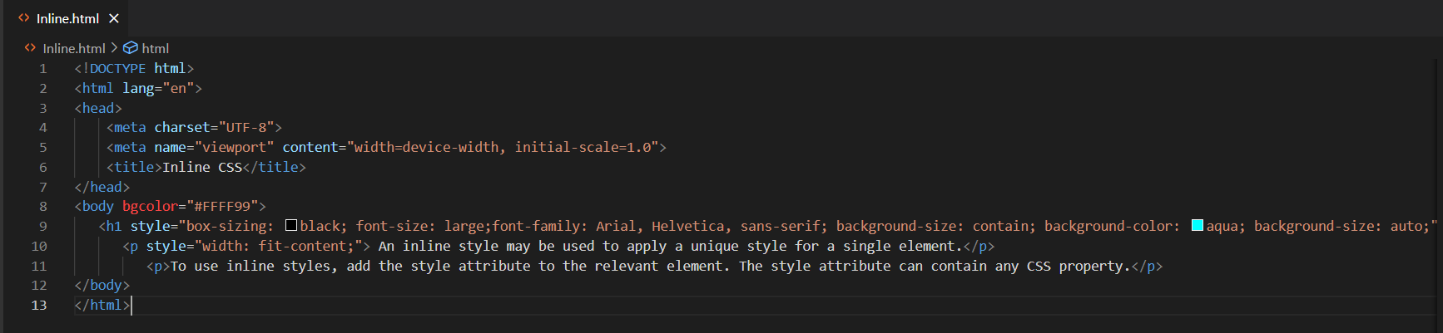

1. **Internal:**

* Internal CSS is used to apply same style to all the tag mentioned in body.
* By adding CSS to the head section of our HTML document, we can embed an internal stylesheet.
* With this we can make any professional webpage in which same style is used for different tags.
* Here is an example of Internal CSS:

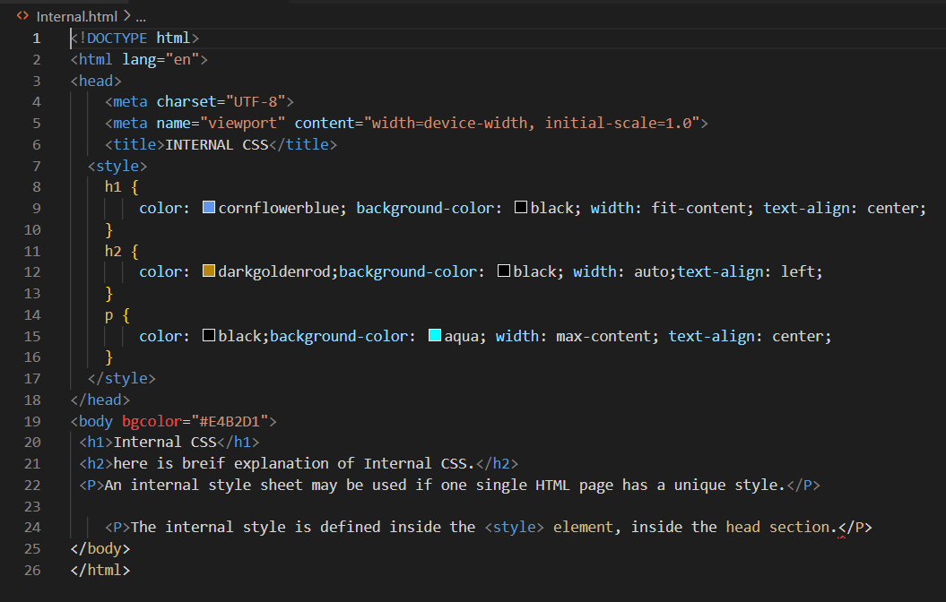

1. **External:** 
   * External CSS is used separate styles from our data page.
   * We can connect to an external stylesheet that separates our CSS from our HTML.
   * For this we have to link our style or attributes file in our head section of programme.
   * By giving reference to the current file all the styles will come from our attached reference file
   * Always give “.css” extension to reference file.

Here is an example of External CSS file:

